Insurance Mobilizer App – Screen Mockups

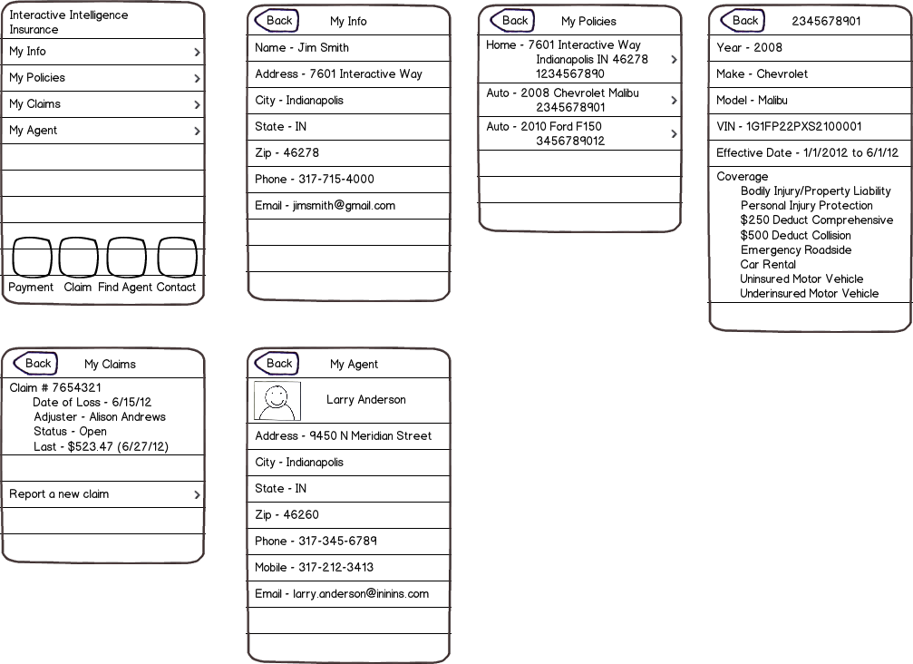

Insurance Mobilizer App – Data Design

Policy

|  |  |  |
| --- | --- | --- |
| Policy_Number | Char(12) | Key / required |
| Policy_Type | Char (3) | Required; PA – personal auto, HO – homeowners, etc |
| Effective_Date | Date | Required; ex. 1/1/12 |
| Expiration_Date | Date | Required; ex. 6/1/12 |
| Policyholder_Id | Char (12) | Required |
|  |  |  |
|  |  |  |

Policy_Auto

|  |  |  |
| --- | --- | --- |
| Policy_Number | Char(12) | Key / required |
| Vehicle_Id | Char (17) | Required; ex. 1G1FP22PXS2100001 |
| Make | Char (30) | Required |
| Model | Char (30) | Required |
| Year | Char(4) | Required |
|  |  |  |
|  |  |  |

Policy_Home

|  |  |  |
| --- | --- | --- |
| Policy_Number | Char(12) | Key / required |
| Address | Char (50) | Required |
| City | Char (50) | Required |
| State | Char (2) | Required |
| Zip | Char(5) | Required |
|  |  |  |
|  |  |  |

Policy_Coverage

|  |  |  |
| --- | --- | --- |
| Policy_Number | Char(12) | Key / required |
| Seq_Nbr | Integer | Required |
| Coverage | Char (75) | Required; ex. Bodily Injury/Property Damage Liability, Personal Injury Protection, Comprehensive, Collision, Emergency Road Service, Car Rental, Uninsured Motorist, Underinsured Motorist, etc |
| Deductible | Char (10) | Optional; ex. $250, $500, etc |
|  |  |  |
|  |  |  |
|  |  |  |

Agent

|  |  |  |
| --- | --- | --- |
| Agent_Id | Char(12) | Key / required |
| Agent_Name | Char (75) | Required; ex. Larry Anderson |
| Agency_Name | Char (100) | Required; ex. Anderson Insurance Inc. |
| Address | Char (50) | Required |
| City | Char (50) | Required |
| State | Char (2) | Required |
| Zip | Char(5) | Required |
| Phone | Char(12) | Required |
| Phone_Mobile | Char(12) | Required |
| Email | Char(50) | Required |
|  |  |  |
|  |  |  |

Claim

|  |  |  |
| --- | --- | --- |
| Claim_Number | Char(12) | Key / required |
| Policy_Number | Char (12) | Required; |
| Report_Date | Date | Required |
| Loss_Date | Date | Required |
| Status | Char(10) | Required; ex. Open / Closed |
| Adjuster_Assigned | Char(75) | Required; ex. Alison Andrews |
| Adjuster_Phone | Char(12) | Required |
| Adjuster_Email | Char(50) | Required |
|  |  |  |
|  |  |  |

Policyholder

|  |  |  |
| --- | --- | --- |
| Policyholder_Id | Char(12) | Key / required |
| First_Name | Char (12) | Required |
| Last_Name | Char | Required |
| Address | Char(50) | Required |
| City | Char(50) | Required |
| State | Char(2) | Required |
| Zip | Char(5) | Required |
| Phone | Char(12) | Required |
| Email | Char(50) | Required |
| Agent_Id | Char(12) | Required |
|  |  |  |
|  |  |  |